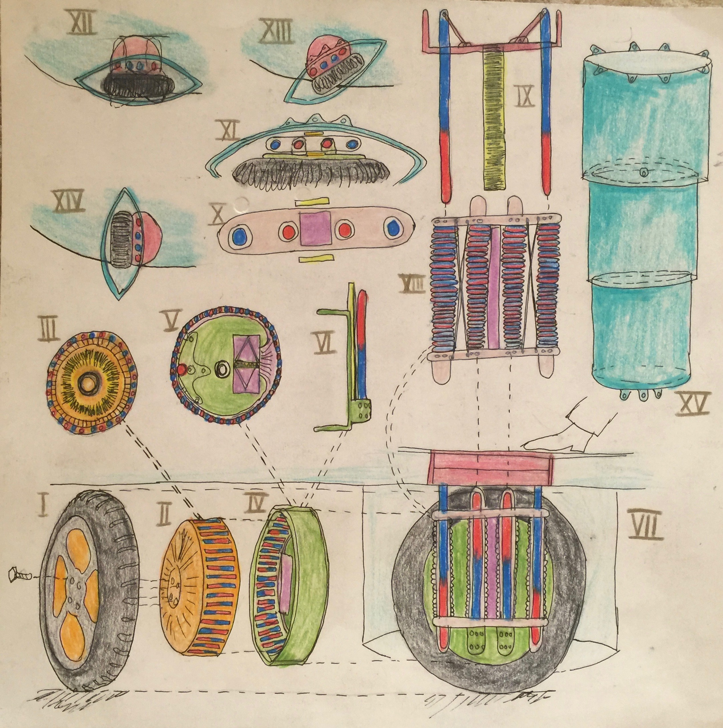Klima Ko-op

Week ending 7 Feb 2016

Wheel Progress Report

# Achieved Mon 1 Feb – Sun 7 Feb 2016

* Metal Cutting
* 3D Printing
* Geometry Definition
* Circuitry
* Principles

# Metal Cutting

* Sorted – good news! David B has agreed to cut the 12mm and 14mm cuts using a friend’s saw. We’ve shipped the raw metal stock to him for one wheel. Meanwhile the metal suppler called Metalbits has agreed to do the 100mm and 121mm cuts. David’s saw did the cuts in about 45 seconds a piece and there are 200 cuts to do. Thank you.
  + We looked at lots of alternatives, such as: duct-tape attaching an angle grinder to a saw bed; renting a metal chop saw; buying a metal saw; using the hand-held jig saw (but we determined the blade would go blunt quickly).

# 3D Printing

* Progress in determining that print-bed levelling in the Z-axis (up towards the sky) was pinching off the filament flow. I’ve read up on auto-bed levelling.
  + Irregularities in the PVA glue layer on the print bed were aggravating the problem, so I’ve removed the print bed and washed it super clean. Some experts advise having many print beds and removing each one after the job (with its print) and putting it in a sink to soak off the glue.
* I’ve purchased five more glass print beds (local glass shop) and have determined that the printer will support 270mm in the X-axis, more than the advertised 250mm and even more than the default configured 230mm.
* I’ve also purchased three more end stops a) because the Y-axis one is currently weak and is strapped together, b) the Z-axis may need to be end-stopped at its top to get auto-bed levelling to work and c) to widen the X-axis..
* The ball bearing races should be arriving soon (from China) to better feed the filament.

# 3D Geometry Definition

* Lots of care in getting the magnetic circuit representation exactly right, with the right air gaps around the parts to allow insertion but not rattling. And to allow maximum transfer of magnetic field around the circuit. Here is the magnetic circuit:

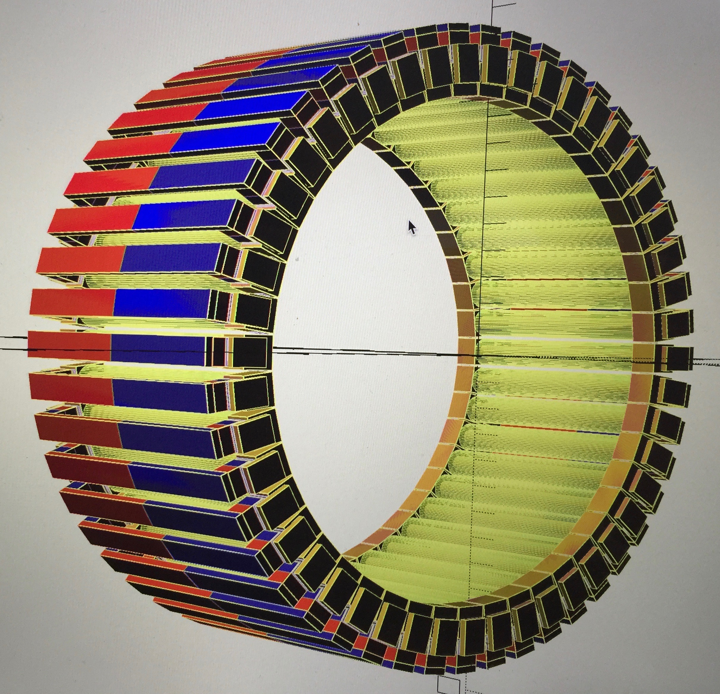

* A key focus for the ‘biscuit tin’ stator design is taking care that everything will fit. The following screen image is the state of play so far in defining the ‘biscuit tin’ of the stator.

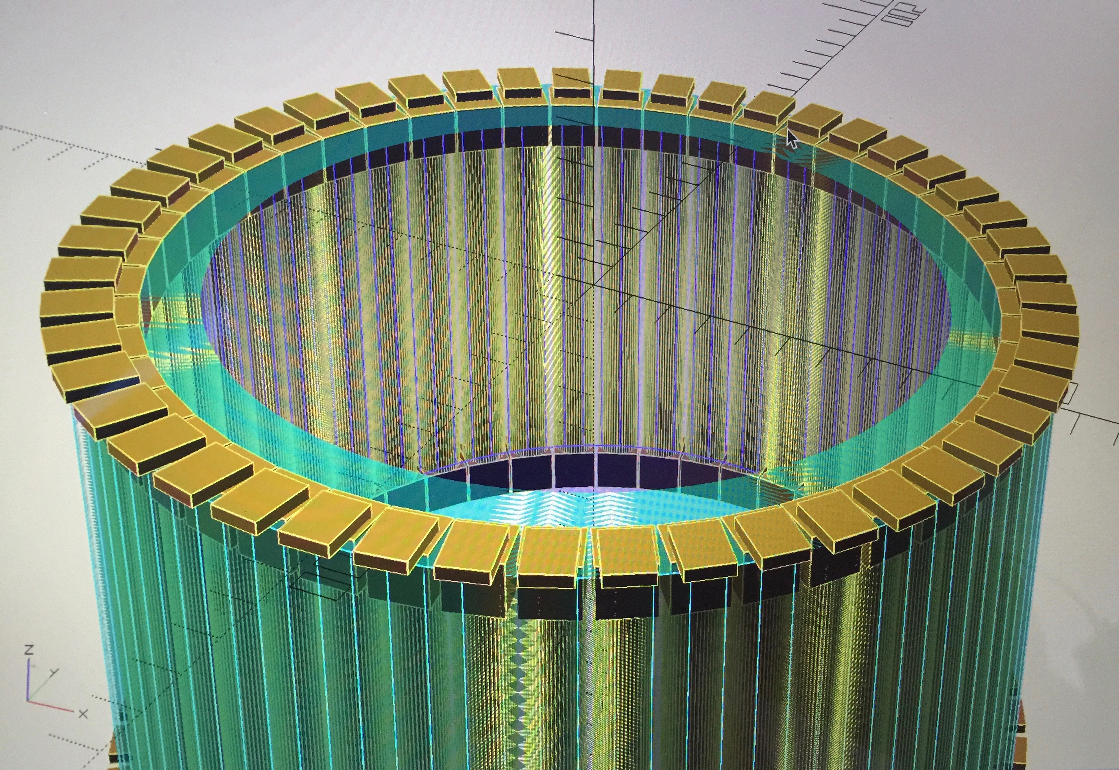

# Circuitry

This is the electromagnetic end of my circuit design. The electromagnetic coils are on the right. On the left is the power supply and the Arduino microcontroller which turns the electromagnets on and off, with the right direction at the right time. The four transistors in the middle simply either turn the coil on one way, or turn it on the other – one way will push the magnets round and the other will pull them round. You push or pull depending on where the magnets are. By applying a 1 to the base of the transistor the other two wires become an ordinary conductor – its as if the transistor is not there – its just a switch.

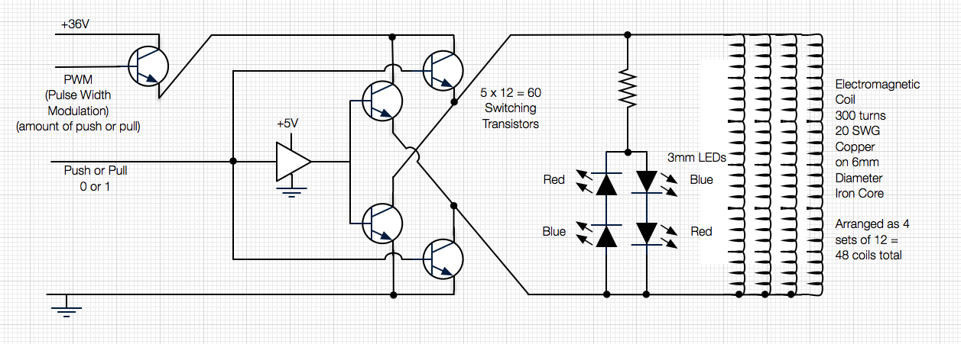

Also not shown here are the various sensors position of the rotor (by optical and magnetic means for belt and braces), temperature, humidity and acceleration (with the last three being lower priority).

I love this stuff! Here is the beginning of the optical circuit: In this trick photo the piece of glass is the real component that I’ve had cut and will use to make the hub waterproof. The yellow hats on sticks are the photoreceptors or sensors. The blue topped hats are the light emitting diodes (LEDs) – ordinary white ones like you find in torches these days. The black slices down the middle will be the holes that let the light in, to the sensors. Light comes from the LEDs in the stator, through a rotating disk on the rotor (which tells position) and then back through the black holes, into the yellow sensors. Seeing which sensors can see light tells you exactly where the rotor is (to about 0.5mm accuracy). The Arduino talks to all these bits. I may not need all ten LEDs but its an experiment to see what’s needed.

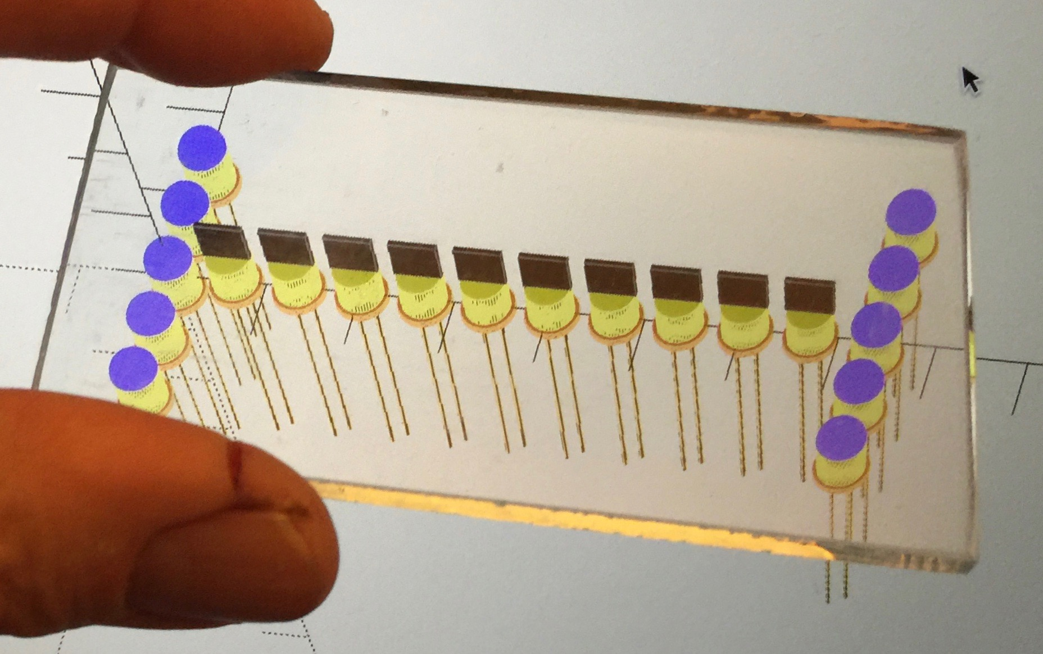

# Procurement

I’ve purchased the detailed wiring bits to hook up the coils to the transistors. Lovely red aluminium hex screws to keep the lid on. Lots of iron bar.

# Some of the Klima Protekta Design Principles

*Principles are things that are universally true and continue to be true over extended periods of time. They provide guidance, and also requirements.*

*Principles are organised into the architectural layers, as appropriate: Geometry, Circuitry, Software, Assembly, and Usability. Multilayer principles apply to more than one layer.*

*Geometry Principle:* ***Test Prints:*** *Don’t 3D print big parts until their design is quite firm. Print slices and aspects to ensure things fit together first.*

*Geometry Principle:* ***Repercussions:*** *If you change one aspect of a geometrical design do analyse the impact on any related parts, especially interlocking parts, and apply all necessary consequential changes as soon as possible.*

*Geometry Principle:* ***Variation:*** *Treat each failed print as a learning opportunity to improve the printer. Determine what was the cause of variation and determine how to eliminate or reduce that cause of variation in the future.*

*Geometry Principle:* ***Tolerances:*** *The 3D printed geometry should be able to accommodate natural variations of dimensions due to natural processes. For example sawn dimensions of metal parts due to cuts. Springs is a good future solution (Mark II) but if necessary glue is a short term fix for excessive rattling.*

*Geometry Principle:* ***Embedded:*** *Even though it is attractive to embed parts (e.g. magnets or nuts) in plastic, it is best not to. Have parts slide in sideways into prepared holes and use slide in covers as necessary.*

*Geometry Principle:* ***Waterproof:*** *All parts should be designed to be waterproof (so that the 400 volt hub motors can drive through flooded roads to a depth of even 600mm! This involves gently squashed seals as found in Tupperware containers.*

*Geometry Principle:* ***Strength****: If the geometry proves too fragile in the wheel then i) use stronger and thicker plastic, ii) embed metal or carbon fibre pieces as in iron reinforced concrete, iii) as necessary switch printing of critical parts to metal, notably aluminium.*

*Multilayer Principle:* ***Repository:*** *Keep the GitHub repository orderly and synchronised across machines. [To Do: Continue to deepen my knowledge of GitHub].*

*Multilayer Principle:* ***Non-Ferrous Materials*** *To avoid disturbing the electromagnetic fields in the traction motor and elsewhere avoid as much as humanly possible using ferrous materials for other purposes around or anywhere near the electromagnetics.*

*Multilayer Principle:* ***Visible behaviour:*** *To aid in the debugging, testing and governance of circuitry and software it is extremely useful to provide immediate visual feedback of behaviours (typically with different coloured LEDs).*

*Multilayer Principle:* ***Beautification****: Keep the layout of code orderly especially with respect to naming conventions, indentation, file include hierarchy. [To Do: automate the beautification process, as it is called].*

*Multilayer Principle:* ***Learning:*** *Continue to deepen my understanding of the languages involved, notably OpenSCAD and the General Library of Relativity.*

*Multilayer Principle:* ***Simple and Beautiful:*** *Simplify and make beautiful: hide complexity and make things just work. Don’t make the user have to think hard to use the product. Make things automatic where practical.*

*Geometry Principle:* ***Number of Print Heads:*** *Mark I is definitely only using one print head on the 3D printer, but a later Mark will exploit two (and only two) print heads. In this way waterproof layers of PET plastic can be spread over nylon. In this way two colour objects can be created, say red and black stripes to indicate high voltage danger. In this way two size geometry prints can be created, say 0.25mm for clean surfaces and 1.0mm for fast infill.*

*Multilayer Principle:* ***Colours****: In Mark I in drawings of permanent magnets red means north pole, and blue means south pole. LEDs that light up optical circuits are white. LEDs that show that electromagnets are working are green for one orientation and yellow for the other. In Mark II dual colour covers for high voltage pins will be black and red striped. In Mark I red anodized aluminium bolts will be used to hold covers on high voltage areas – note these are not load bearing situations.*

*Geometry Principle:* ***Hex Keys:*** *Assembly and disassembly will be with as few types and sizes of tool as possible. The default is to use Allen keys (which are six sided, hexagonal) within screw heads.*

*Circuitry Principle:* ***Saw First:*** *Saw components (such as Vero boards) to size before soldering any components onto that board.*

*Circuitry Principle:* ***Edge Wires:*** *Connecting wires to a board should go to the outer most row of holes or pins only and not clutter the interior of the board. (as much as possible and practical [AMAPP])*

*Circuitry Principle:* ***Crush:*** *For connecting wires to wires or wires to components in places where there is not a circuit board support then squeeze/crush joints are preferable to solder as they are less susceptible to vibration.*

*Circuitry Principle:* ***Double Connections:*** *as a way of making critical wires more reliable ensure that they are attached (physically and electrically) in two places not just one. So that if either one were to come off the circuit would keep working.*

*Circuitry Principle: No exposed conductors – this is so important for safety. It doesn’t apply to 5volt information circuitry, but for 36v (later 400 volt even 1000 volt) it is crucial.*

*Circuitry Principle:* ***Fault tolerance:*** *belt and braces. As much as possible the design should use two mechanisms to achieve crucial ends. For example wheel position shall be measured both optically and with Hall effect.*

*Circuitry Principle:* ***Dedicated Holes:*** *Only one wire to a hole (AMAPP) as this makes for more reliable joints.*

*Circuitry Principle:* ***Wires******Support****. If wires or solder joints become detached then see if this is (or could be) from vibration or shock. Then design the part to keep the wires etc. more secure so that they can’t move about so much. Also do this as preventative design.*

*Circuitry Principle:* ***Epoxy Embed****: If the circuitry proves too fragile in the wheel then embed it in epoxy resin. [To Do if necessary].*

The picture below shows a physical mock-up of the hollow interior of the stator (as seen in the pictures above). The vertical bars show where the electromagnets will be. This chocolate box is remarkably similar in size to the stator cavity in terms of diameter (but not height – it will be 100mm about tall). In the picture on the left is the Arduino board, with a ‘shield’ expansion board sitting on top of it – they plug together neatly. On the shield are three comparator chips that interpret the light levels coming off the photo sensors. Top left of the shield is the three axis accelerometer (with four holes in its corners). Top right of the shield is the blue humidity and temperature sensor. The other board, on the right, is the high voltage board. It will be cut roughly in two so that the bit with transistors (black and silver) will be used and the other half (on the right) not used. At the minute only some of the transistors are in position. There will be ten from top to bottom, in six columns, so you see the left column is populated. These transistors, in sets of five are as per the circuit diagram above. The white triangle in the circuit diagram is an inverter, and there will be invertor chips on the far right of the right board. Both boards will have various resistors on them. Around the edge of the tin, above these boards will be the wiring loom hooking up the electromagnets and touch sensors. The white bit is a failed print of the lid of the box.

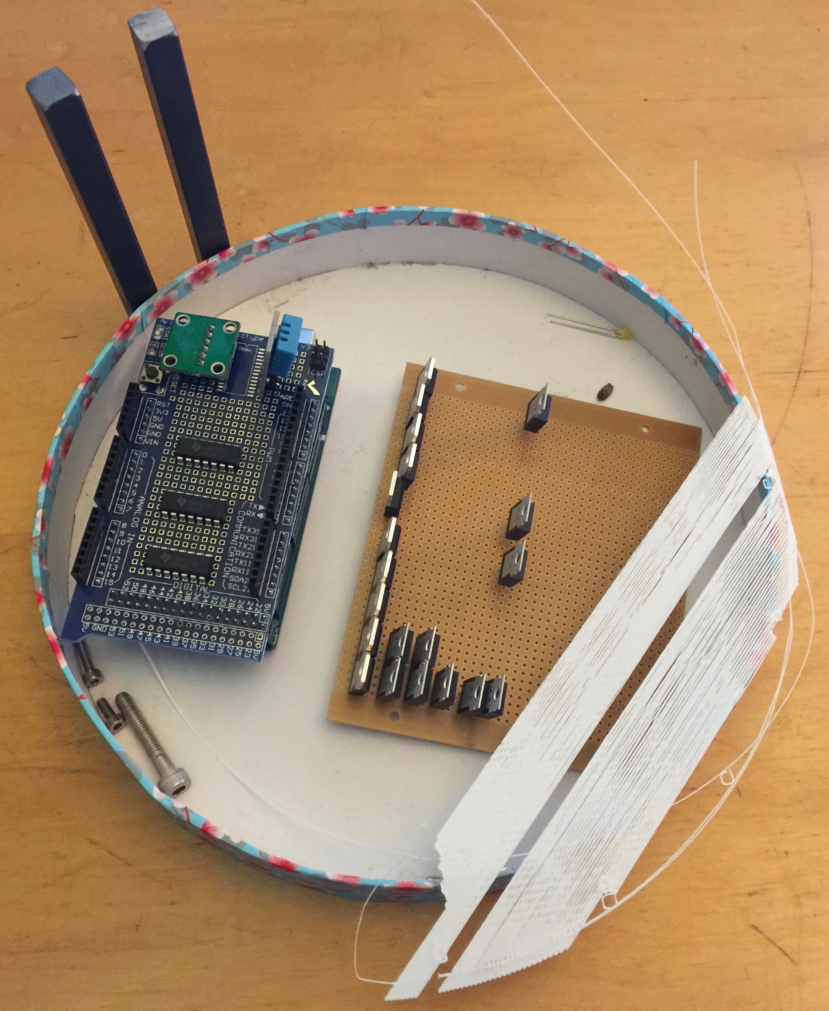

I’ve been doing a detailed map of the Arduino pin outs and almost all of the 54 digital I/O and 16 analogue input pins will be used!